


THE REAL SCHOOL
LEARNER’S EMPOWERMENT ACTIVITIES
P.4 INTEGRATED SCIENCE.
Plant life
TOPIC Plant Life

Victoria P/S

Golden Junior
School

Makindye Junior School

An excellent first grade and excellent character for every pupil

INDEX NO

NAME………………………………………………………………………CLASS: …………………………
SCHOOL: ……………………………………………………………………………………………………….

Theme: Word of living things
Topic: plant life
Learning outcome: The leaner appreciates the importance of plants in our daily
Back ground knower: Living things.
Session one.
Relevance and functionality. As learner to understand plants and their characteristics.

Competences
As learner you will;
_defines a plant
_ gives characteristics of plants.
_ gives groups of plants
_ characteristics of plants.
_defines flowering plants
_ gives examples of flowering plants.
_ defines non-flowering plants.
_ gives examples of non- flowering plants.
Background knowledge. Living things

Key learning principles. Plants are living things that use chlorophyll to make their food called starch.
Content.
Plants
Plants are living things that use chlorophyll to make their food called starch.
characteristics of plants.
- Plants grow.
- Plants respire.
- Plants reproduce.
- Plants respond to stimuli.
Groups of plants.
Flowering plants.
Non-flowering plants
Examples of flowering plants
- Mango plant
- Sun flower
- Black jack.
- Cotton plant.
- Orange plant
- Paw-paw plant
- Grape plant
Non flowering plants
Non- flowering plants are plants which do not bear flowers
Some non- flowering plants reproduce by means of spores which others reproduce by means of seeds.
Example of non-flowering plants.
- Pines
- Ferns
- Mosses
- Liverworts
- Horst ails
- Cedar
Cypress
- Fir
Spruce

Mini activity.
1. What do you understand by the term plant?
__________________________________________________________________________
2. Identify any other type of plants apart from flowering plants.
_____________________________________________________________________________
3. State down any two characteristics of plants.
______________________________________________________________________________
4. What do plants use to make their own food?
___________________________________________________________________________
5. Name the kind of food made by plants.
__________________________________________________________________________

6. Name the type of food made by plants.
_________________________________________________________________________
7. How do plants reproduce?
___________________________________________________________________________

8. The diagram below shows a plant. Use it to answer questions 4 and 5
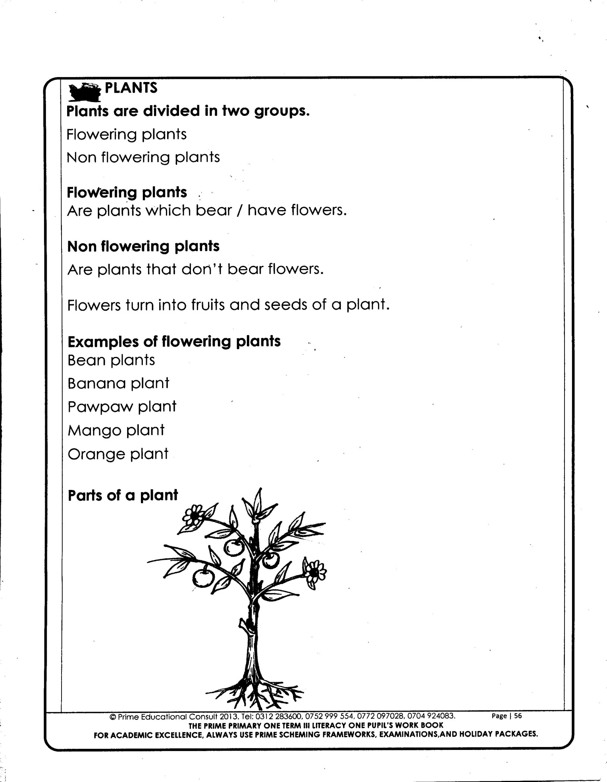

9. To which group of plants done the above plant belong?
__________________________________________________________________________
10. Use an arrow and letter M to show the part of A plant that has chlopyhll
_________________________________________________________________________
11. Apart from flowering plants, write down any other type of plant you know
__________________________________________________________________________
12. Identify any three characteristics of plants.
i) ___________________________________________________________________________
ii) __________________________________________________________________________
iii) _________________________________________________________________________
MEGA ACTIVITY

1. Define the term plant.
_________________________________________________________________________
2. How important is chlorophyll to a plant
_________________________________________________________________________
3. What do you understand by the term living things?
________________________________________________________________________
4. Apart from plants, written any other type of living things found in the environment
___________________________________________________________________________
5. What do you understand by the term non- flowering plants?
_________________________________________________________________________
6. How do flowering plants reproduce?
_________________________________________________________________________
7. Apart from seeds, give any other way how non- flowering plants reproduce
________________________________________________________________________
8. Below is a diagram of plant. Use it to answer question 5 and 6
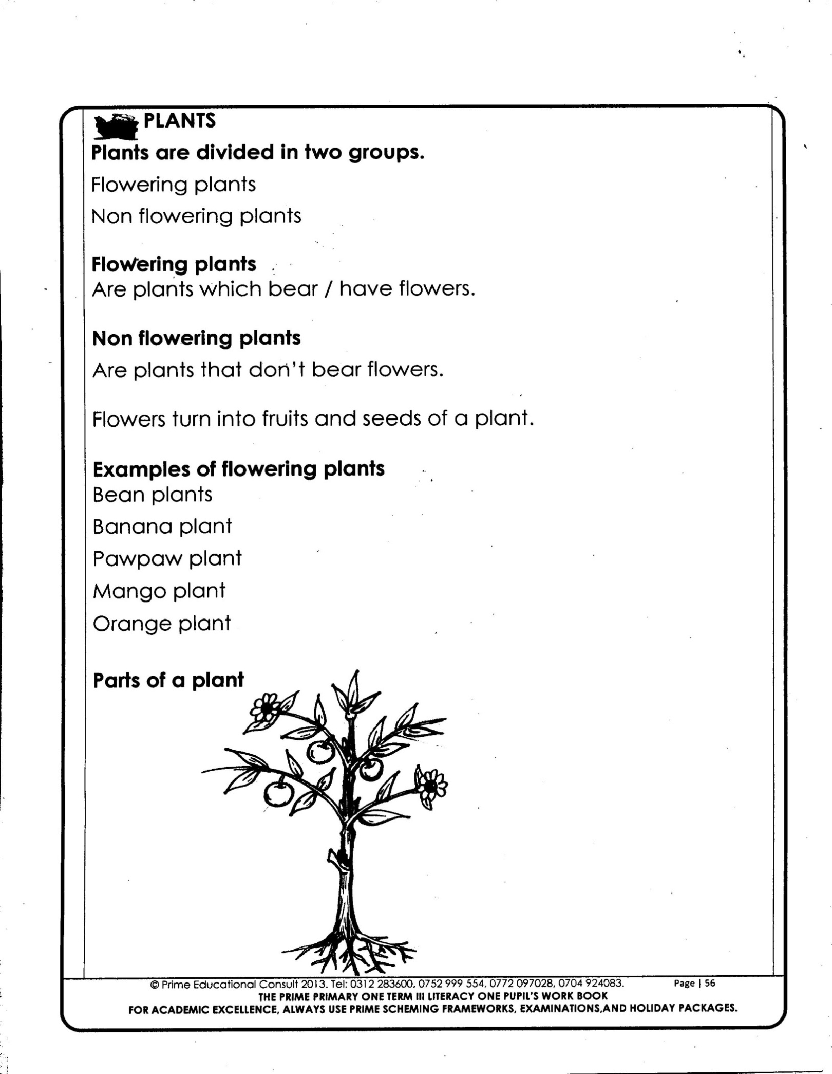

h

5. Name the type of plant shown above.
________________________________________________________________________
6. Name part marked h on the diagram above
_________________________________________________________________________
7. Write any four non- flowering plants you know.
i) __________________________________ ii) __________________________________
iii) __________________________________ iv) ________________________________
8. Why do you think a mango plant is referred to as flowering plant?
_________________________________________________________________________
9. Apart from a mango plant, write any three other flowering plant you know
i) _________________ ii) _________________________ iii) ________________________
10. How important is chlorophyll to a flowering plant.
__________________________________________________________________________
11. Give any two ways how plants reproduce.
i) ________________________________________________________________________
ii) _______________________________________________________________________
12. To which group of things in the environment do plants belong?
_________________________________________________________________________

Theme: Word of living things
Topic: plant life
Learning outcome: The leaner appreciates the importance of plants in our daily.
Session. 2.
Relevance and functionality. As a learner to understand the parts of a plant and their functions.
Competences As a learners you will ;
- Gives the parts system of a flowering plant
- Gives functions of each part of flowering plant.
- Writes and describe the systems of a flowering plant
Draws and labels parts of a leaf and gives their functions
Background knowledge. Examples of non-flowering plants
key learning principle.
Shoot Upper part.
Root lower part
Learner centered approach
Name one part of a plant we eat
Content
1. Identify any one feature used to differentiate a flowering plant from anon- flowering
___________________________________________________________________________
2. How important are roots to a plant?
__________________________________________________________________________
3. Give any one way how stomata of a plant are similar to the gills of a fish.
_________________________________________________________________________

Systems of a flowering plant.
Terminal bud
leaf
flower
branch
node
stem
root
fruit
Axillary bud
Shoot system
Root system

Shoot system
_ defines a leaf
_ draws identifies parts of a leaf their functions
Functions of parts of a flowering plant
- Terminal bud: It is the growing tip of the plant
- Axillary/ lateral bud: It is the bud that develops into a branch
- Axil: This is the angle between the leaf and the stem.
- Node: It appoint where a leaf is attached on the stem. It also holds the buds.
- Internode: Is the region/ distance between two nodes.
- Flower bud: It develops into a flower.
- Leaves: They make food for the plant.
- Roots: They absorb water and minerals salts from the soil for the plant.
- Stomata: For breathing.
MINI ACTIVITY
1. Identify any one feature used to differentiate a flowering plant from anon- flowering
___________________________________________________________________________
2. How important are roots to a plant?
__________________________________________________________________________
3. Give any one way how stomata of a plant are similar to the gills of a fish.
_________________________________________________________________________
System of a flowering plant.
_ Shoot system.
_ Root system.
shoot system.
This is the part grows above the ground.
It develops from the plumule of the seed during germination.
Parts of the shoot system
_Leaves Nodes Internodes Axil
_ Terminal bud Branches Leaves.
_ Axillary Fruit stem
Root system.
This is the part of the part that grows in the soil from the radicle of the seed.
It develops from the radicle of the seed during germination.
parts of the root system.
_Tap root _ Root cap
_Root hairs _Fibrous.

_ Lateral roots
MINI ACTIVITY.
1. Write the two systems of a flowering plant.
i) _______________________________________________________________________
ii) _______________________________________________________________________
2. Draw and name two parts of a shoot system.
i) _______________________________ ii) ______________________________________
3. How important is the root system to a plant during germination.
____________________________________________________________________ 4. Identify any one feature used to differentiate a flowering plant from anon- flowering
___________________________________________________________________________
5. How important are roots to a plant?
__________________________________________________________________________
6. Give any one way how stomata of a plant are similar to the gills of a fish.
____________________________________________________________________________

Theme: Word of living things
Topic: plant life
Learning outcome: The leaner appreciates the importance of plants in our daily.
Session. 3
Relevance and functionality. As a learner to understand types of root
Competences As a learners in your unit;
_Give types of root system
_Names examples of plants with tap root and fibrous root system
_States functions of each part of the tap root system
Background knowledge. Systems of a flowering plants.
key learning principle.
Root system is a part of a plant that grows into the soil from the radicle.
Learner centered approach
Uproot different plants and observe their roots
Content
Types of roots system.
Tap root system
Fibrous root system
NB. tap root and fib root system are also called primary roots because they develop from the radicle of the seed
Fibrous root system
This is where are many roots growing randomly with no main root.
_ It is a characteristic of monocotyledonous plants
Examples of plants with fibrous root system
Maize, sorghum, sugarcane, millet, grass, where Rice, Barley etc

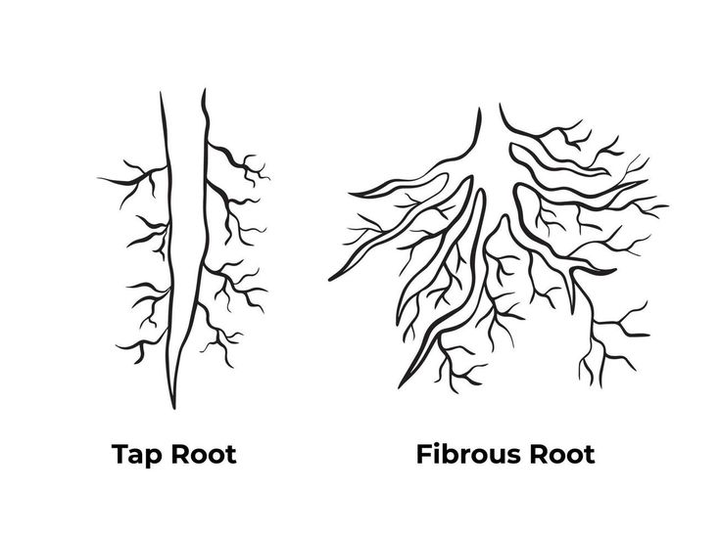
A diagram showing a plant with fibrous root system

Mini activity
1. Name the two types of root system.
i) ____________________________________ ii) ___________________________________.
2. Write down any two plants with fibrous roots system.
______________________________________________________________________________
_____________________________________________________________________________
3. Give the two systems of a flowering root system
i)____________________________________ ii) _____________________________________
4. Write any one differences between fibrous root system and tap root system.
_____________________________________________________________________________
Tap root system
This is a system with a main root from which lateral roots develop.
- They grow directly from the radicle of the germinating embryo.
- They are commonly found in dicotyledonous plants
Examples of plants with tap root system
Beans, Groundnuts, orange, mango, soyabeans etc.
Diagram showing a plant with atap root system
Tap root
Tap root
Lateral root
Tap root
Root cap
Root hair

Functions of the parts of the tap root system
1.
- It protects the growing root from the mechanical injury.
- It also helps the root to penetrate through the soil.
2. Root hair
- They absorb water and mineral salts from the soil (through osmosis)
3. Main root.
- It conducts water and mineral salts from the soil to plants.
- It supports the plant firmly in the ground.
4. Lateral roots.
- They carry water and mineral salts.
- They support the plant firmly in the ground.
Types of roots secondary roots / adventitious
- Secondary roots are roots which grow from other parts of plant rather than the radicle.
Types of roots
a) Prop roots
These are adventitious roots which grow on stems of a plant.
_ Prop roots give extra support to a plant during flowering stage.
_ They are commonly found in cereals
Examples of plants with prop roots
Maize, millet, wheat, sorghum, sugarcane etc.
Mega Activity
1. Name the part of plant that holds the plants firmly in the soil.
___________________________________________________________________________
2. Give one example of secondary roots.
____________________________________________________________________________
3. Give one reason why prop roots are regarded as secondary roots.
_____________________________________________________________________________
4. State one difference between primary roots and secondary roots.
_____________________________________________________________________________
5. Write any three types of roots.
i) __________________ii)________________________ iii) ___________________________
6. Give the importance of prop roots.
____________________________________________________________________________
7. Name any two functions of roots to plants.
___________________________________________________________________________
___________________________________________________________________________
8. Give any two functions of roots to plants.
___________________________________________________________________________
___________________________________________________________________________
9. Mention any two functions of roots to animals
___________________________________________________________________________
___________________________________________________________________________

Theme: Word of living things
Topic: plant life
Learning outcome: The leaner appreciates the importance of plants in our daily.
Session. 4
Relevance and functionality. As a learner to understand types of roots and their functions.

Competences As a learners you will ;
Describe types of roots
Background knowledge. Prop roots
key learning principle.
Types of roots.
These are roots that grow from other parts of a plant rather than the radicle
Learner centered approach
Apart from absorbing water, state any other two uses of roots to a plant.
Content
b) Breathing roots
These are roots which are commonly found on plants that in wetlands
They act as breathing organs to plants which grow in water logged areas/ swamps.
Diagram
Examples of plants with breathing roots
Mangrove
c) Buttress roots
These are adventurous roots which grow and appear above the ground on bigger trees.
A diagram showing buttress roots
d) Clasping roots.
These are adventitious roots which enable plants to climb.
_ They are found in climbing and parasites plants.
Examples of plants with clasping roots
Vanilla, money plants etc.
A diagram showing a diagram with a clasping root system
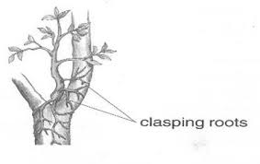

e) Silt roots
These are cereal roots which grow from the base of the above the ground level.
_ They are found in plants which grow in muddy areas in swamps.
A diagram showing silt roots
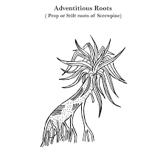

c) storage roots
These are roots which store food for a plant.
Examples of plants with storage roots
Carrots, cassava, sweat potato
Uses of roots to plants
_ Roots absorb water and mineral salts from the soil.
_ Roots hold the plant firmly into soil.
_ Some roots are used for breathing.
Uses of roots to man.
- Roots are eaten as food.
- They are source of money.
- They are used as herbal medicine.

Theme: Word of living things
Topic: plant life
Learning outcome: The leaner appreciates the importance of plants in our daily.
Session. 5
Relevance and functionality.
Competences As a learners you will ;
Background knowledge.
key learning principle.

Learner centered approach
Content
Stem
Is the part of flowering plant on which leaves flowers and fruits develop.
Functions of stems to plants
- They hold the leaves to get sun light.
- They hold the flower for easy pollination.
- They conduct water and mineral salts from the roots to leaves.
- Some stems store food.
- Some stems are used for propagation
Functions of stems to man
- Some stems are eaten as food.
- Some are used as herbal medicine.
- Some stems are used as firewood to people
Types of stems
_ Upright stems
_ Climbing stems
_ Underground stems
_ creeping stem
Diagram

LEAVES

- A Leaf is a structure on a plant where photosynthesis and gaseous exchange takes place.
- Leaves are parts of the shoot system and develop from the node of the plant.
PARTS OF ALEAF
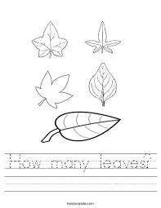
Apex
Margin
Vein
Leaf stalk
Stomata
Leaf blade

FUNCTION OF PARTS OF ALEAF

- Midrib/mid vein: It Transports water and nutrients from the leafstalk to vein. It conducts already manufactured food to the leaf stalk.
- Veins: They supply water and mineral salts from the midrib to all parts of the leaf. Collects manufactured food from all parts of the leaf to the midrib.
- Leaf base: It fixes the leaf firmly to the branch or stem.
- Leaf stalk/petiole: It attaches the leaf to the stem or branch. It supplies water to the leaf from the branch or stem. It conducts manufactured food to the stem or branch.
- Stomata: These are tiny openings on the leaf. They are used for breathing. They are also used for transpiration
- Lamina( leaf blade) It is used for making food/photosynthesis. It is used for respiration.
MINI ACTIVITY.
1. Define a leaf.
___________________________________________________________________
2. Which part of a leaf attaches the leaf to the stem or branch
_____________________________________________________________________
3. Identify the part of a flowering plant that develops into a flower
____________________________________________________________________
4. State the part of a leaf that enables respiration to take place.
___________________________________________________________________
5. Draw a flowering plant and use letter M to locate the axillary

MEGA ACTIVITY
1. Name the part of plant where photosynthesis and gaseous exchange take place.
______________________________________________________________________
2. Which part of the leaf supplies water and mineral salts from the midrib to other parts of the leaf.
_______________________________________________________________________
3. Apart from gaseous exchange, name any other two processes that take place in leaves
_________________________________________________________________________
4. Name the green pigment found in leaves.
______________________________________________________________________
5. How important is the above pigment during photosynthesis?
______________________________________________________________________
6.Apart from the root system, write the other type of system of plants you know.
_____________________________________________________________________
7. How is the stomata of a leaf the lungs of humans similar
_____________________________________________________________________
8. Identify any two parts of a root system.
____________________________________________________________________
9. The diagram below shows a leaf. Use it to answer questions 10 and 11
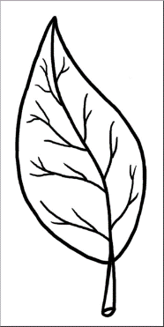
A
N

10. Give the importance of part A on the leaf
____________________________________________________________________
11. Use an arrow and letter N to show the part of leaf that is used to manufacture food all parts of the leaf to the midrib.
______________________________________________________________________
12. To which system of a plant does leaf belong?
____________________________________________________________________
PHASE FOUR

leaf venation
Key Learning principles
This is the arrangement of veins in the leaf
competences.
The learner: _ Gives examples of plants with different leaf venations.
_ Gives the types of leaf venation and their examples

types of leaf venation
- Network leaf venation.
- Parallel leaf venation
network venation
This is the where veins make a net like structure.
The veins interlock each other and form a net like structure.
It is a characteristic of dicotyledonous plants
examples of plants with network leaf venation
- Bean plants
- Avocado plants
- Soya beans plants
- Hibiscus plants
- Black jack plant
- Mango plants
- Jackfruit plants

Diagram showing net work leaf venation
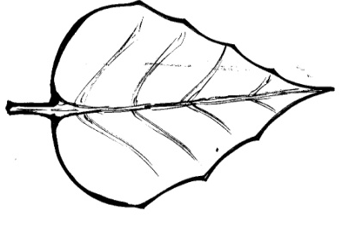

parallel leaf venation
- This is where veins run from the leaf stalk to the apex of the parallel to one another.
- This name is derived from palled lines which don’t meet.
- It is a characteristics of monocotyledonous plants
examples of plants with palallel leaf venation
Maize plants Banana plant
Grass Millet plant
Sugarcane plant Wheat plant
Sorghum plant Rice plants

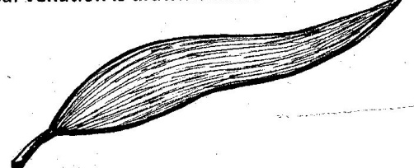
Diagram showing parallel leaf venation

types of leaves
- Simple leaves
- Compound leaves
simple leaves
- A simple leaf is leaf one leaf blade on the leaf stalk.
- Their leaf is not divided into leaflets
Chacteristics of simple leaves.
They have one leaflet on the stalk.
They have one margin
They have one stalk.
examples/categories of simple leaves
These are determined by the shape of the margin.
- Simple serrated leaf
- Simple lobed leaf
- Simple entire leaf
- Simple divided entire leaf
- Simple palmate leaf
- Simple lanceolate leaf
1. Simple serrated leaf
They have a toothed margin.
The margin has a structure which is like a blade of a saw e.g., apple tree leaves
2. Simple entire leaves:
These have smooth margin plants with simple entire leaves e.g., mango plants
Jack plants.
Avocado plant
3. Simple palmate leaves
The name is given due to the appearance of the leaf which is resembling an open palm/ hand having lobes radiating from a common point e.g paw paw plant leaves
4. Simple lobed leaves
These have shaped margins
They have lobes/ divisions extending less than half way to the middle of the base
simple longalate leaf.
Examples
Maize plant leaves
Wheat leaves
Grass
illustractions showing different simple leaves
Simple Simple entire simple
Serrated leaf leaf palmate leaf
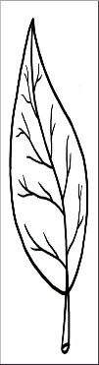
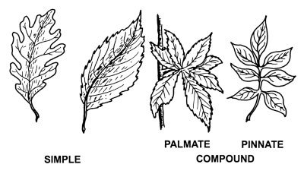
A
N

Simple lobed leaf Simple divided entire leaf
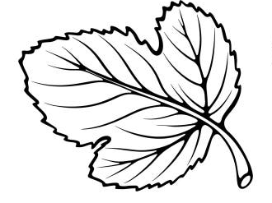

MINI ACTIVITY
1. Write two types of leaf venation
________________________________________________________________________
2. What do you understand by the term leaf venation
_________________________________________________________________________
3. Identify any three examples of simple leaves
i) _______________________ ii)________________________ iii) _____________________
4. Give any two examples of plants with network leaf venation
i) __________________________________ ii) ___________________________________
Compound leaves
- These are leaves with many leaflets on one stalk.
- Their leaf blades are divided into leaflets and each leaflet has its own small stalk called rachis
- The leaflets are divided up to the leaf stalk
NB: The word compound means combination or something consisting of two or more different parts so the name compound leaves
chacteristics of compound leaves
They have many leaflets.
They have many leafstalks

examples of compound leaves
- Compound pinnate
- Compound digitate leaves
- Compound bipinnate
- Compound trifoliate
compound pinnate leaf.
Pinnate arrangement has leaf lets arranged in pairs opposite one another along the main stalk e.g. acacia plant.
compound pinnate.
These are pinnately compound leaves in which the leaflets are themselves divided twice pinnate) e.g. Jacaranda
compound trifoliate leaf.
These compound leaves have three leaflets developing from the main stalk e.g. in bean plants, soya plants (Tri) means three
compound digitate leaf.
These have leaflets resembling the fingers/ digits of a hand form a spread hand e.g.
Cassava leaves.
diagram showing examples of compound leaves
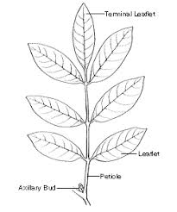
Compound Compound Compound
Pinnate bi-pinnate trifoliate
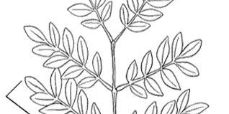
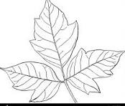

Compound
digitate
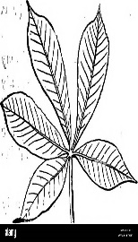

MINI ACTIVITY
1. Which type of leaves has many leaf lets on one stalk?
________________________________________________________________________
2. Write down any two characteristics of compound leaves
i) ______________________________________________________________________
ii) _____________________________________________________________________
3. Identify the four examples of compound leaves.
i) ____________________________ ii______________________________________
ii) ____________________________iv) _____________________________________
MEGA ACTIVITY
1. State the two types of leaves in plants
i) ___________________________________ ii) ____________________________________
2. Name the type of leaves with one leaflet on the stalk.
_______________________________________________________________________
3. What is meant by the term compound leaves
_______________________________________________________________________
4. State any two characteristics of simple leaves
i) ______________________________________________________________________
ii) _____________________________________________________________________
5. Mention any three examples of simple leaves
i) ____________________________________________________________________
ii) ___________________________________________________________________
iii) ___________________________________________________________________
6. Give any four importance of leaves to people.
i) ________________________________ ii) _________________________________
ii) ________________________________ iv) ________________________________
7. Mention any three examples of compound leaves
i) _____________________________________________________________________
ii) ____________________________________________________________________
iii) ____________________________________________________________________
8. Name two plants with simple entire leaves in the environment
i) ________________________________ ii) _________________________________
9. Which type of compound leaves do bean plant have?
___________________________________________________________________________
10. State any two importance of leaves to plants.
i) _________________________________________________________________________
ii) _________________________________________________________________________
11. State two differences between simple and compound leaves.
i) _________________________________________________________________________
ii) _________________________________________________________________________
12. Name the part of the plant where photosynthesis take place
___________________________________________________________________________

Theme: Word of living things
Topic: plant life
Learning outcome: The leaner appreciates the importance of plants in our daily.
Session. 6
Relevance and functionality.
Competences As a learners you will ;
Background knowledge.
key learning principle.

Learner centered approach
Content
Transpiration
Transpiration is the process by which plants lose water in inform of vapour to the atmosphere mainly through stomata.
_ Plants use oxygen to respire.
_ They use stomata in leaves for gaseous exchange.
_ The process of respiration in plates gives out carbon dioxide.
Experiment to show that plants carry out transpiration

Requirements
_ A potted plant
_ A transparent polythene paper with no holes
Procedures
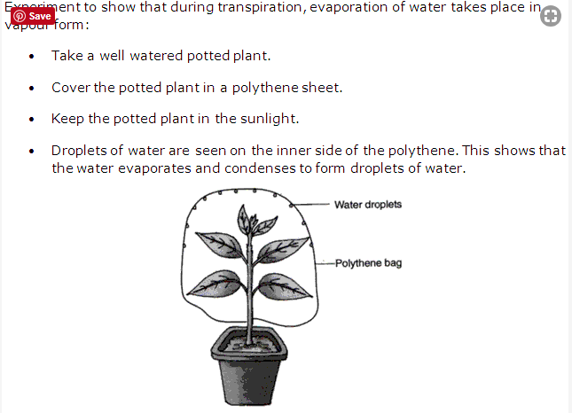

Observation
_ Drops of water are seen inside the polythene bag
Conclusion.
Plants respire
Importance of transpiration to plants
_ It cools the plant
Importance of transpiration to the environment.
_ It helps in rain formation.
Ways o through which plants control the rate of transpiration
- Some leaves have a layer of wax which covers the stomata
- Some plants shed their leaves during dry season.
- Some plants grow needle like leaves.
- Some plants have thick leaves with few stomata.
Factors affecting the rate of transpiration
1. Sun light 6. Number of stomata
2. Temperature.
3. Humidity.
4. Wind.
5.Size of the leaf
Photosynthesis.
Is the process by which plants make their own food called starch.
Raw materials for photosynthesis.
_ Carbon dioxide Water
Conditions necessary for photosynthesis.
Carbon dioxide, sunlight, chlorophyll water
Importance of photo synthesist
It enables plant to make food.
Importance of photosynthesis to animals
It enables animals to get food.
It produces oxygen to animals.

Relevance: The leaners understand parts of a flower
SESSION 7
Competences
- Understands the meaning of a flower.
- Draws and names parts of a flower and gives functions of each part
- Draws a pistil and stamen of a flower
Leaner centered approach
- 1. Mention any one use of flowers to plants
___________________________________________________________________________
Key leaning principles.
A flower is a reproductive part of a flowering plant functions-uses importance
Content.
A flower is reproductive part of a flowering plant
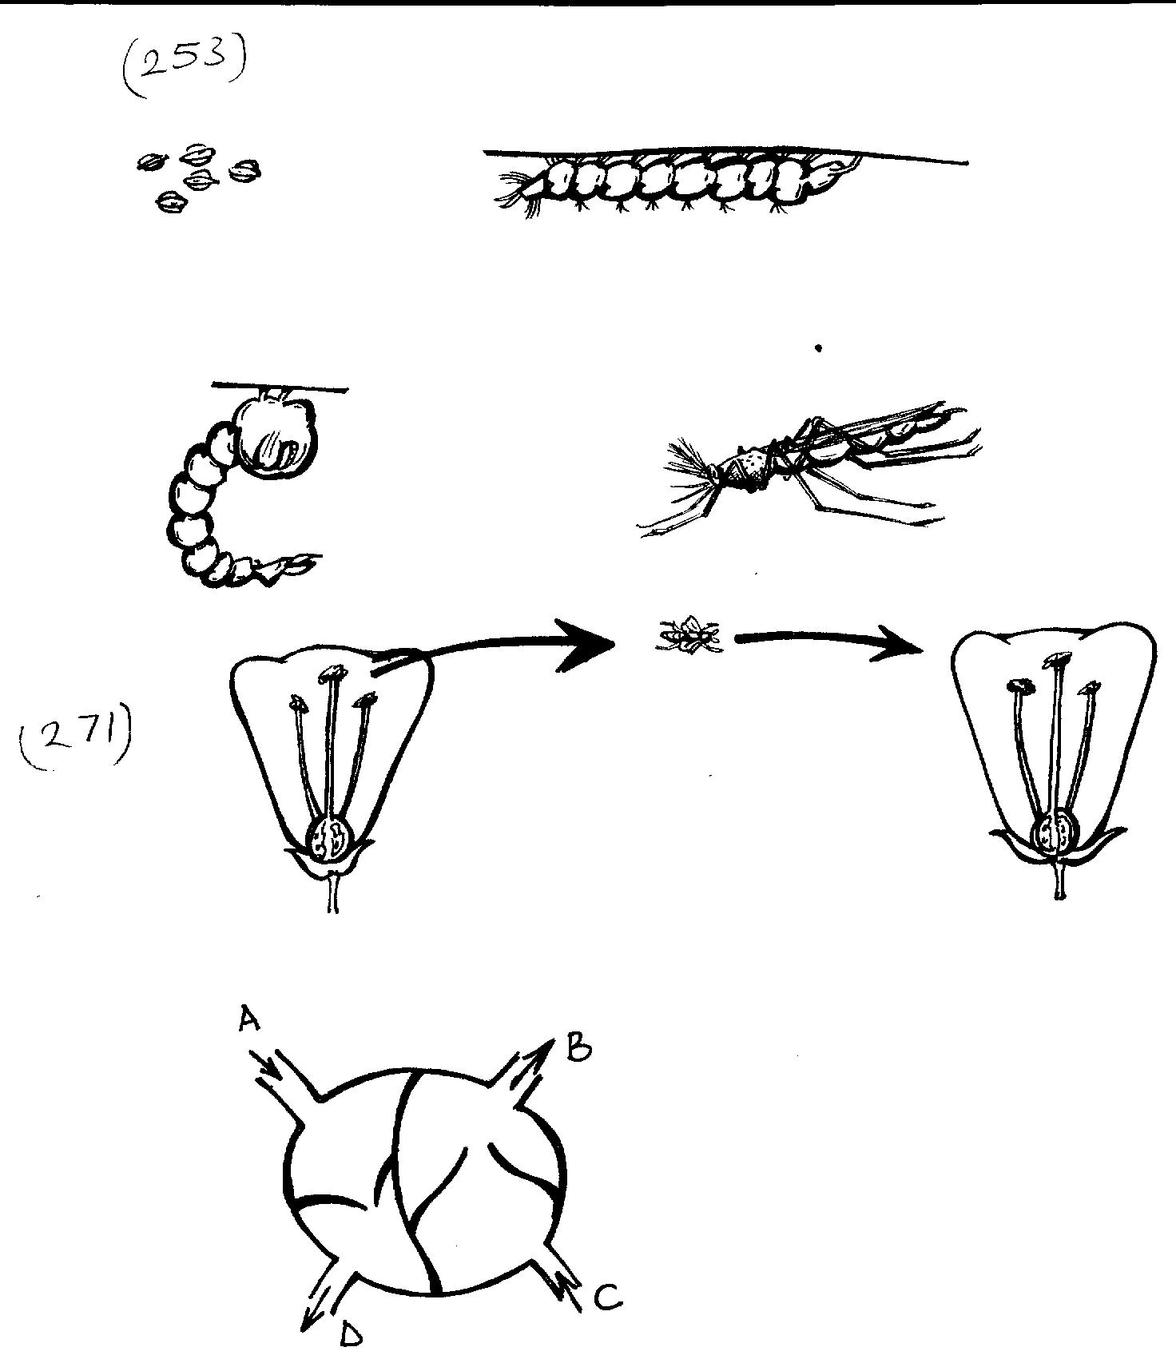
Parts of flower and their functions Draw diagram showing parts of the flower
Stigma
Filament
Petals
Ovary
Sepals
Ovules
Anther
Style
Stalk
Stigma

Importance of each part
Flower stalk: It holds the flower on the stem.
Receptacle.: This is the expanded part of the stalk bears the sepals and petals
Sepals: They protect the flower when it is still in stage /young
: They make food for the flower. (They are green)
: A group of sepals is called calyx
Petals: They protect the inside parts of the flower.
: They are brightly colored and attract pollinators e.g birds and insects.
: They are scented and produce nectar
: A group of petals is called corolla.

Anthers : They produce and store pollen grains.
: Pollen grains are the male reproductive cells of a flower
Filament. _ It holds the anthers in right position for pollination
Stigma. _ It receives pollen grains from the anthers during pollination.
Style. _ It holds the stigma in the right position from pollination.
_ It is where the pollen grains pass from the stigma to the ovary.
_ Joins the stigma to the ovary.

Ovary. _ It produces and stores ovules.
_ It is where fertilization takes place.
_ Develops into a fruit after fertilization.

Ovules. _ They are the female reproductive cells.
_ They develop into seeds after after fertilization.

Min activity
1. What is a flower?
___________________________________________________________________________
2. Mention any two parts of a flower.
i)___________________________ ii) ___________________________________________
3. How do we call a group of petals?
_________________________________________________________________________
4. Give any one importance of an ovary.
_________________________________________________________________________
The pistil and stamen

structure of the pistil.
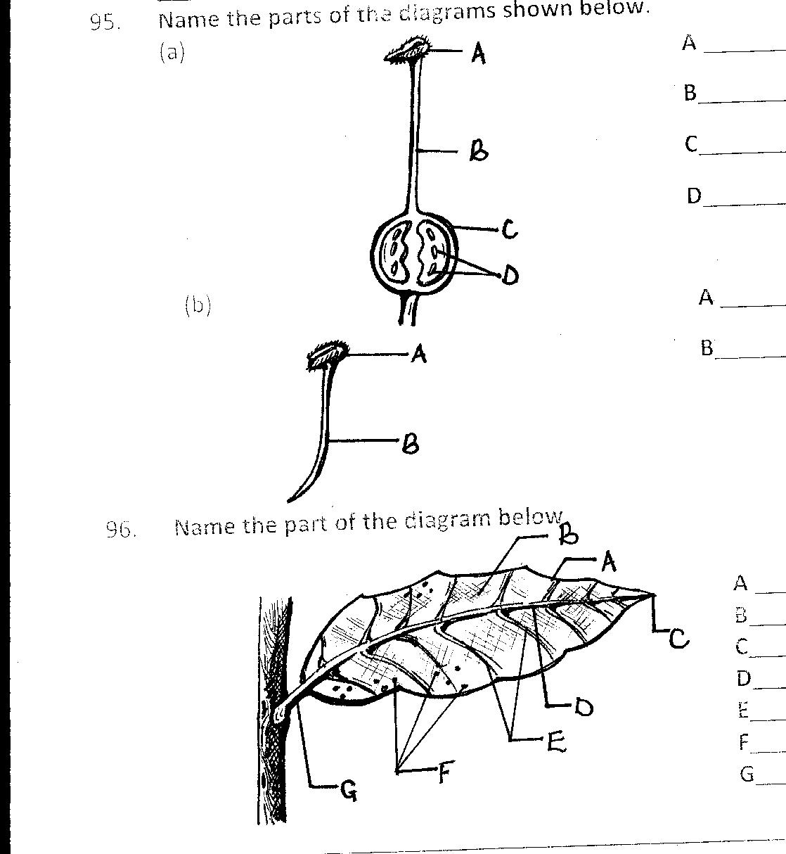
Stigma
Style
Ovules
Ovary

The pistil carpel
This is the female part of a flower parts that make up the pistil stigma, style, ovary, ovules
The stamen: This is the male part of a flower
Parts that make up the stamen .
Anther head, pollen grains, filament
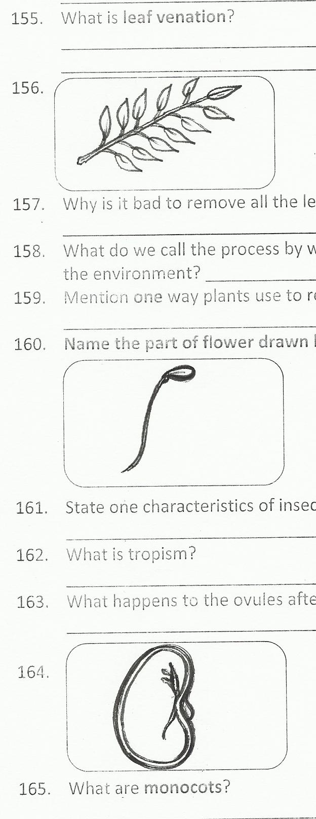
Structure of the stamen
Anther head
Filament

Min activity
1. How do we call.
________________________________________________________________________
a) female part of a flower?
__________________________________________________________________________
b) male part of a flower?
___________________________________________________________________________
MEGA ACTIVITY
1. What is meant by a flower?
___________________________________________________________________________
2. State the function of flowers to plants.
___________________________________________________________________________
3 . Write any four parts of a flower.
i)_________________ii) ___________________ iii) ________________iv) ______________
4. Name the part of a flower that develops into a fruit.
____________________________________________________________________________
5. Name the part of the flower that produces pollen grain
____________________________________________________________________________
6. State any three importance of flowers to people
i) ___________________________________________________________________________
ii) __________________________________________________________________________
iii) _________________________________________________________________________
7. What name is given the group of sepals?
_____________________________________________________________________________
8. Give the function of the stigma during pollination
___________________________________________________________________________
9. Draw the following,
a) pistil

b) stamen

10. What general name is given to the following.
a) male part of a flower
__________________________________________________________________________
b) Female part of a flower
_________________________________________________________________________
11. Why do some flowers have bright colored portals?
___________________________________________________________________________
12. Where does fertilization take place in a flower?
___________________________________________________________________________
13. what happens to the following after fertilization?
___________________________________________________________________________
i) The ovules

ii) The ovary

session 9
Theme: word of living thing things.
Topic: plant life.
Learning outcome. The leaner appreciates the importance of plants in our daily life.
Session 9
Background knowledge. Living things
Relevance’ The leaner under stands pollination.

Competences.
The leaner, _ Understands the meaning of pollination.
_ Identifies types of pollination,
_ Characteristics of self-pollinated flowers,
_ Characteristics of cross-pollinated flowers,
_ Differences between self-pollinated flowers’
Learner centered approach
Name any two examples of insects that are commonly found on flowers.
Key leaning principle
Pollination is the transfer of pollen grains from the anthers to the stigma of a flower.
Characteristics_ features.
Types_ groups.
CONTENT. Pollination is the transfer of pollen grains from the anthers to the stigma of a flower.
types of pollination
Self-pollination.
Cross pollination.
Self-pollination is the transfer of pollen grains from the anthers to the stigma on the
Same flower
characteristics of self-pollinated flowers.
_ They have nectar
_ They have brightly colored petals to attract insect pollinators.
_ They have large petals.
Plants which carry out self-pollination.
Tomatoes barley
Peanuts rice
Wheat potatoes

Diagram showing self-pollination in flowers
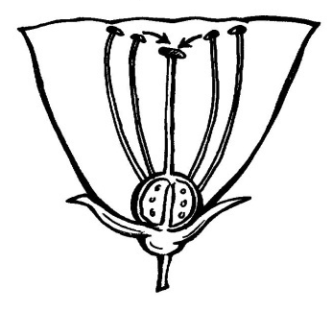

Cross pollination
Is the transfer of pollen grains from the anther of one flower to the stigma of another flower on different plant but of the same kind.
Plants which early out cross pollination
Coconut plants cowpeas plants
Pawpaw maize plant
characteristics of cross-pollinated flowers.
_ They have dull colored petals
_ They do not produce nectar.
_ They anthers are above the stigma.
The diagram showing cross pollination.
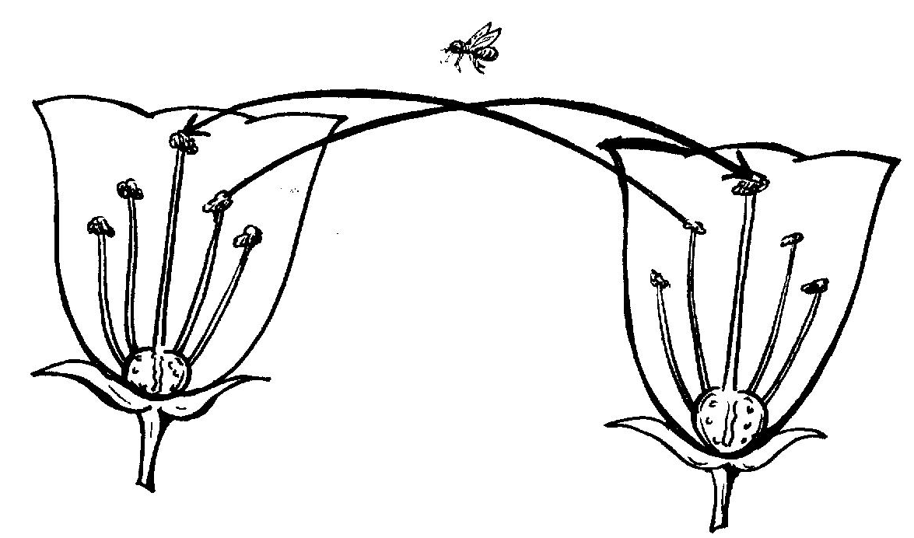

Hands on activity
1. What is pollination.
____________________________________________________________________________
2. Give any two types of pollination
i)____________________________________ii) ____________________________________
3. Mention any two characteristics of self-pollination
i)__________________________________________________________________________
ii) ________________________________________________________________________
Difference between self-pollinated flowers and cross-pollinated flowers

Self-pollinated flowers | Cross pollinated flowers
Pistils and stamen are on the same flower  Large amounts of pollen grains produced.  _Anthers are raised higher than the stigmas  _Filaments are longer than styles | Pistil and stamen are on different flowers  Small amounts of pollen grains produced.  _Stigma are raised higher than anthers  Style is longer than filaments
MEGA ACTIVITY
1. What is meant by the term pollination.
__________________________________________________________________________
2. State the two types of pollination in plants.
i)_____________________________ ii) _________________________________________
3. In one sentence, explain self-pollination.
___________________________________________________________________________
4. Name any two plants that undergo self-pollination
i) _________________________________ ii) _____________________________________
5. What is meant by cross pollination?
___________________________________________________________________________
6. Name two examples flowering plants.
i)_______________________________ii)_________________________________________
7. Mention any three plants that carry out self-pollination.
i) ___________________ii) ____________________ iii) ___________________________
8. Give any two characteristics of self-pollinated flowers.
i) _________________________________________________________________________
ii) _________________________________________________________________________
9. State any two differences between self-pollinated and cross-pollinated flowers.
i) _________________________________________________________________________
ii) _________________________________________________________________________
10. Give two ways some flowers are able to carry out self-pollination.
i) ________________________________________________________________________
ii) _______________________________________________________________________
11. Name the types of pollination where pollen grains move from the anthers to stigma
On the same flowers.
12. Mention any two advantages of cross pollination.
i) _________________________________________________________________________
ii) _______________________________________________________________________

Theme: word of living things.
Topic: plant life.
learning outcome; The leaner appreciates the importance of plants in our
dairy life.
Background knowledge. Living things.
Relevance: The leaner understands agents of pollination.
Session 10
competences
The leaner,
_ Give agents of pollination.
_ Gives examples of flowers pollinated by birds and their characteristics.
_ Gives chatterati’s of insects pollinated flowers and their examples.
_ Gives differences between insect pollinated flowers.
_ Gives importance of pollination to plants and people.
Leaner centered approach
1. In your units discuss and write the meaning of pollination.
Key leaning principles.
cartelistic_ features.
Pollination is the transfer of pollen grains from the another’s to the stigma of a flower.
Importance _uses, advantages.
Content.
Agents of pollination.
These are things that transfer pollen grains from the anthers to the stigma of a flower.
Examples of agents of pollination.
Insects like bees, butterflies, moths, beetles, birds like sun birds, humming birds
Animals like man and bats which feed on nectar.
_wind
_water
a) birds
Some visit flowers to feed on nectar and up pollinating the flowers.
They are attracted by the brightly colored petals of the flowers.
Pollen sticks on to their legs and bodies and move it to other flowers.
They have along slender and curved beak to suck nectar from the flowers.
Examples of birds that pollinate flowers.
_sunbirds.
_ hummingbirds.
b) Animals Egberts.
Some water plants are pollinated by water.
The pollen grains float on water surface until they find the stigma of a water plant.
Insects.
Some insects visit flowers to feed on nectar and up pollinating the flowers e.g the h, bees and butter flies.
_They produce sent /good smell to attract insect pollinators.
_ They have a sticky stigma above the anther heads.
_ They produce few pollen grains.
NOTE: Months pollinate flowers at night.
_They are attracted by the scent produced by flowers at night.
_Bees visit flowers to collect nectar and pollen.
HANDS ON ACTIVITY

1. Mention any two agents of pollination.
i) ________________________ ii) ______________________________________________
2. Which insects pollinates flowers at night?
___________________________________________________________________________
3. Give any two examples of birds that pollinate flower.
i) _______________________________ ii) ______________________________________

WIND
Some flowers are pollinated by the help of wind.
Characteristics of wind pollinated flowers.
_They have dull colored petals.
_ They do not produce nectar.
_ They do not produce scent.
_ They produce a lot of pollen grains.
_Their pollen grains are light.
_They have along hairy stigma
_ The flower is small and not easily seen.

Difference between wind pollinated flowers and insect pollinated flowers
Insect pollinated flowers | Wind pollinated
_Have brightly colored petals  _ Have large petals.  _ produce scent  _produce nectar  _ produce few pollens grains  _ Have sticky stigma.  _ Have heavier pollen grains | Have dull colored petals  _Do not produce scent.  _Do not produce nectar.  _produce a lot of pollen grains.  _Have hairy stigma.  _Have lighter pollen grains

MEGA ACTIVITY

1. Name the insect that pollinates flowers at night.
_______________________________________________________________________
2. Name any three agents of pollination.
i) _________________ ii) _____________________________ iii) _________________
3. State any two characteristics of insect pollinated flowers.
i) ______________________________________________________________________
ii) _____________________________________________________________________
4. Why are petals of insect pollinated flowers brightly colored?
________________________________________________________________________
5. State any three differences between insect pollinated and wind polluted flowers.
i)_______________________________________________________________________
ii) _____________________________________________________________________
iii) _____________________________________________________________________

6. How useful are bees to plants?
________________________________________________________________________
7. Why do bees visit flowers.
_______________________________________________________________________
8. Identify any two substance bees collect from flowers.
i) __________________________ ii) ________________________________________
9. Why do some flowers produce scent?
_______________________________________________________________________
10. How are moths able to pollinate flowers at night?
_______________________________________________________________________
11. State any three importance of flowers to people.
i) _____________________________________________________________________
ii) ____________________________________________________________________
iii) ____________________________________________________________________
12. Give any two importance of flowers to people.
i) _____________________________________________________________________
ii) ____________________________________________________________________

THEME: Word of living things.
TOPIC: Plant life.
learning out come: The leaner appreciates the importance of plants in our daily life.
Session 11.
Background knowledge: living things.
Relevance: The leaner understands fertilization in plants.
Competence:
The leaner:
_ Understands fertilization in plants.
_ State what happens after fertilization.
_ Gives importance of flowers to people and plants.
_Defines as seed and importance of seeds.
Leaner centered approach
1. What is a plant?
________________________________________________________________________
key learning principles
Fertilization is the union of male and female garments to form an embryo.
Importance _ uses, functions, advantages.
Content:
Fertilization in parts.
Fertilization. Is the union of male and female gametes to form an embryo
Fertilization in plants takes place in the ovary the flower.
A gamete is reproductive cell.
In flowering plants, the male gametes are the pollen grain and the female gametes are the ovules
Fertilization happens after pollination.
Process of fertilization.
The pollen grains fall in the stigma and start to germinate.
Each pollen grain grows a pollen tube through the style.
The pollen tube reaches the ovule in the ovary.

Events after fertilization.
_ The ovules develop into seeds.
_ The ovary develops into a fruit.
_ The petals and stamen whither, dry and fall off.
Why do they fall off.
_They are useless after fertilization.
_ They dry easily.
Min activity
1. why do petals and stamen fall off?
_________________________________________________________________________
2. What is fertilization?
________________________________________________________________________
3. Mention any two events after fertilization.
i)________________________________________________________________________
ii) _______________________________________________________________________
Importance of flowers to people.
_ They are used for decoration.
_ Some flowers are used are used in making of perfumes.
_ Flowers are used to make dyes.
_ Flowers are also used for study purpose.
_Flowers are used to show love and respect.
_ Some flowers are a source of food.
_ Flowers are sources of income when sold.
Importance of flowers to plant
Flowers produce fruits and seeds which are planted to produce new plants.
A SEED.
Seed is a fertilized ovule containing the embryo.
Importance of seeds
Seeds grow into new plants.
Seeds store food for the plant.

Mini Activity
1. How are flowers important to plants.
__________________________________________________________________________
2. What is a seed?
_________________________________________________________________________
3. Give any two importance of flowers to people.
i) ______________________________________________________________________
ii) ______________________________________________________________________
MEGA ACTIVITY
1. Name the insect that pollinates flowers at night.
__________________________________________________________________________
2. Name any three agents of pollination.
i) __________________ ii) __________________________ iii) ______________________
3. State any two characteristics of insect pollinated flowers.
i) _________________________________________________________________________
ii) ________________________________________________________________________
4. Why are petals of insect pollinated flowers brightly colored.
__________________________________________________________________________
5. What happens after fertilization.
__________________________________________________________________________
6. Mention ant two process of fertilization.
i) _____________________________________ ii) _________________________________
7. what name is given to a reproductive cell?
___________________________________________________________________________
8. What is fertilization.
____________________________________________________________________________
9. Give any two importance of flowers to animals.
i) _________________________________________________________________________
ii) ________________________________________________________________________
10. What is meant by term a seed?
__________________________________________________________________________
11. From which part of flowers do seeds develop?
__________________________________________________________________________
12. How are seeds important to people.
_________________________________________________________________________
SESSION 12
THEME: word of living things.
TOPIC: plant life.
Leaning out come: The leaner appreciates the importance of plants in our daily life.
Background knowledge: living things.
Relevance: The leaner understands types of seeds.

Competences:
The Lerner;
_ Identifies types of seeds.
_ Characteristics of dicotyledonous seeds.
_ Examples of plants with dicotyledonous seeds.
_ Draws and Ables bean seed.
_ Gives the functions of each part of A bean seed.

Key learning principles.
Types groups.
Characteristics features.
Functions_importance,uses.

Leaner centered approach.
In your units discus and write examples of seeds.

Content:
Types of seeds.
Seeds are grouped according to the number of cotyledons a seed has.
1. Monocotyledons seeds / monocot seeds.
2. Dicotyledonous seeds /Dicot seeds.
dicotyledonous seeds.
_These are seeds with two cotyledons.
_ They are produced by dicotyledonous plants.
_ Such seed can easily be spirit into two parts since they have two cotyledons.
Characteristics of dicotyledonous seeds.
_ They have two cotyledons.
_ They store food in the cotyledon.
_ They undergo epigeal germination.

Min activity.
1. What does the word Di mean?
__________________________________________________________________________
2. Mention any two characteristics of dicots.
i) ________________________________________________________________________
ii) ________________________________________________________________________
3. Give any one type of seeds.
___________________________________________________________________________
Examples of dicotyledonous seeds.
Bean seeds mango seeds pumpkin seeds
Coffee orange seeds peas
Watermelon seeds, groundnut seeds Avocado seeds

Parts of a bean seed.
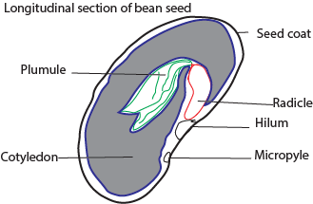

functions of each part.
seedcoat/ testa
_ It protects their parts of the seed.
plumule.
_ It grows into the shoot system after germination.
hilum.
_ It is a scar left behind which attached the seed to the pod.
cotyledon.
_ It stores food for the embryo.
_ It provides food to the germinating embryo in dicotyledonous seeds.
micropyle.
_ It is a small hole which allows air and water into the seed during germination.
embryo.
_It is made up of the radicle and plumule grows in a new plant.
Min activity
1. Mention any two examples of dicotyledonous seeds.
i) _________________________________ ii) ____________________________________
2. How is a seed coat important to a seed?
_________________________________________________________________________
3. Name the part of a seed that grows into the root system after germination
__________________________________________________________________________

4. Name the part of the bean sed that develop into a new plant.
_________________________________________________________________________
5. Mention the type of germination dicotyledonous seed under go.
__________________________________________________________________________
6. Name the type of roots found in dicotyledonous plants
__________________________________________________________________________
7. Which leaf venation is found in leaves of dicotyledonous plants?
__________________________________________________________________________
8. State the function of the cotyledon to the germinating seed.
___________________________________________________________________________
7. State any two characteristics of dicotyledonous seeds.
i) __________________________________________________________________________
ii) _________________________________________________________________________
7. Name any four examples of dicotyledonous seeds.
i) ______________________________________ii) ________________________________
iii) ____________________________________ iv) ________________________________
8. What are dicotyledonous seeds?
__________________________________________________________________________
9. How are the following parts important to bean seeds.
a) Plumule
_________________________________________________________________________
b) Testa
___________________________________________________________________________
10. What is a seed?
__________________________________________________________________________
11. Mention any two importance of seeds to animals and people.
i) ________________________________________________________________________
ii) _______________________________________________________________________
12. Give any one type of seeds.
_________________________________________________________________________
THEME: word of living things.
Topic: Plant life.
Learning outcome: The learner appreciates the importance of seeds in our daily life.
Theme: world of living things.
Topic: Plant life
Back ground knowledge: living things.
Relevance: The learner understands mono cotyledon us seeds.
Session 13:
Competences.
The Learner:
_ Gives characteristics of monocotyledonous seeds.
_ Gives examples of plants with monocotyledonous seeds.
_ Draws and labels maize seed.
_ Gives the functions of each part of maize seed
Leaner centered approach.
In your units discuss and write example of monocotyledonous seeds.
Key learning principle.
Characteristics features.
Function importance, uses.
Content.
Monocotyledonous seeds.
These are seeds with one Cotyledon.
Mono means one.
Such seeds cannot be easily split into two apart since they have one cotyledon.
Characteristics of monocotyledonous.
_ They have one cotyledon.
_ They undergo hypogeal germination.
_ They store food in the endosperm.
Examples of monocot seeds.
Maize Rice seeds sorghum seeds.
Wheat seeds millet oats.
Barley.
NOTE: These seeds are also called cereals or grains.
A maize grain (fruit)
A maize grain is not a seed but a fruit.
It is a fruit because it has two a scar i.e., style car and the stalk scar.
parts of a maize grain
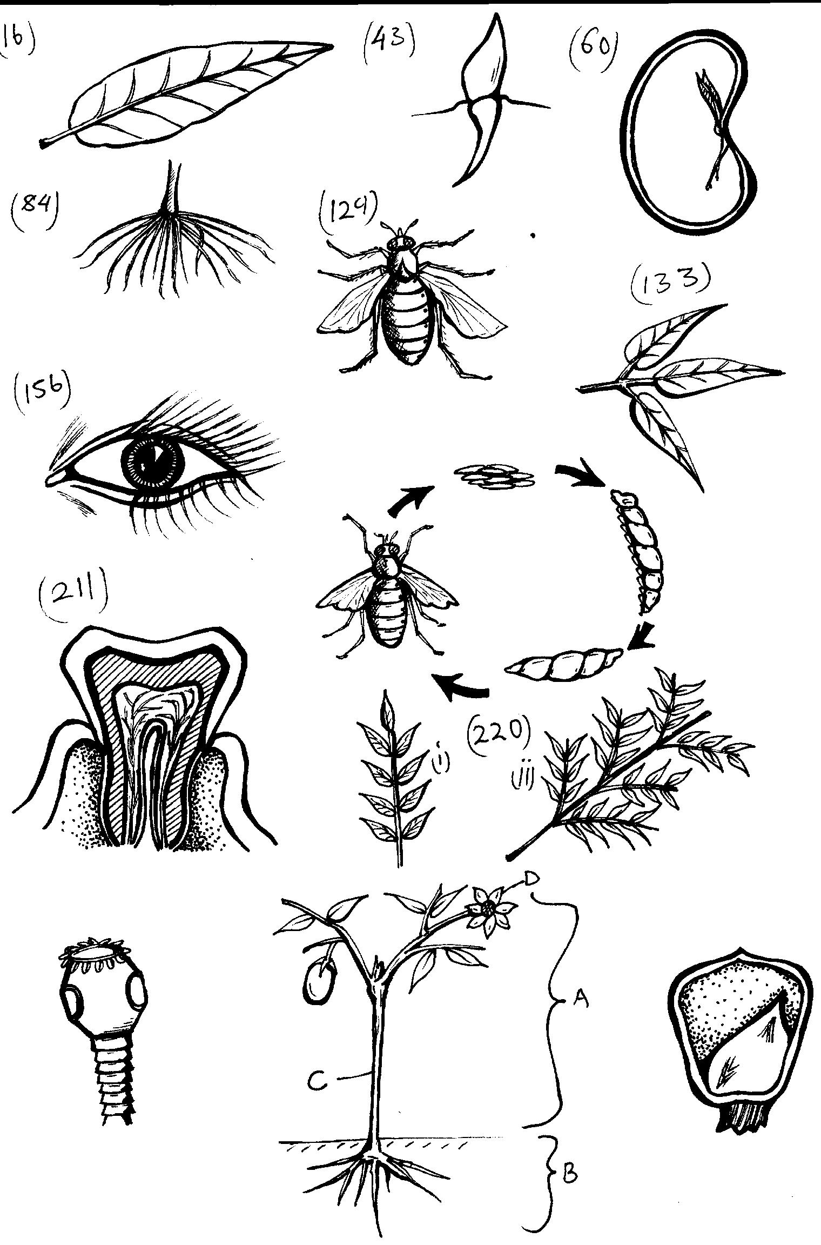
Style scar
Stalk scar
Seed coat
plumule
Cotyledon
Radicle
Endosperm

Functions of each part.
Testa (seed coat).
_ It is the hard outer covering of the fruit.
_ It protects the inner parts of the grain from damage.
Endosperm.
_ It stores food for the embryo in monocotyledonous seeds.
Cotyledon.
_It absorbs food from the endosperm and supplies it to the embryo during germination.
Style scar.
_ It is apart where the style was attached.
Stalk scar.
_ It is where the grain is attached to the maize cob
Embryo.
_ It is apart that grows into a new plant.
_ It consists of two parts ie plumule and radicle.
Plumule.
_ It grows into the shoot system after germination.
Radicle.
_It grows into the root system after germinations.
Min activity
1. Give two examples of monocots seeds.
i) ______________________________ ii) _________________________________________
2. Why is a maize grain called a fruit.
___________________________________________________________________________
3. Mention any two characteristics of monocots.
i) _________________________________________________________________________
ii) _________________________________________________________________________
MEGA ACTIVITY.
1. What is meant by term seed?
____________________________________________________________________________
2. From which part of flowers do seeds develop?
___________________________________________________________________________
3. Name any one type of seeds in our environment.
__________________________________________________________________________
4. What are monocotyledonous seeds.
__________________________________________________________________________
5. State any two characteristics of monocotyledonous seeds.
i) ________________________________________________________________________
ii) ________________________________________________________________________
6. How important are prop roots to sorghum plants?
__________________________________________________________________________
7. Name the type of roots found in cereals.
__________________________________________________________________________
8. Why is a maize grain called a fruit not a seed?
__________________________________________________________________________
9. Identify the leaf venation millet plants have.
__________________________________________________________________________
10. Name the part of a maize grain that stores food for the growing embryo.
__________________________________________________________________________
11. Which part of a seed develops into the following?
__________________________________________________________________________
a) Shoot system.
__________________________________________________________________________
b) root system.
__________________________________________________________________________
c) young plant.
__________________________________________________________________________
12. State the function of cotyledon to the germinating embryo.
__________________________________________________________________________
13. How useful is attest to a seed?
__________________________________________________________________________
14. Name the two scars of a maize grain.
i) _______________________________________ ii) ______________________________
15. Which type of germination do monocots seeds undergo?
________________________________________________________________________

THEME: world of living things.
Topic: Plant life
Learning outcome: To enable the leaner understand and descramble the plant life.
Session 13
Back ground knowledge: Seed
Relevancy and functionality:
_ Understands different types of germination, conditions, necessary for seed to germinate
Competences. The learner defines epigeal and hypogeal germination.
_ gives examples of seeds with hypogeal and epigeal germination.
_ explains the process of germination.
_ Cories out an experiment about germination.
_seed viability and dormancy.

Key learning principle: Hypogeal germination is the type of germination where the cotyledon remains below the ground level.
_ Hypogeal germination occurs in all monocotyledonous seeds eg wheat, maize, sorghum
Learner centered approach.
Observe two germinating seeds of different plants and note what you see.
Content

Germination
This is the development of a seed into seedling
Types of gemination.
Epigeal gemination.
Hypogeal gemination
Hypogeal gemination is where cotyledon comes above the ground.
Examples of plants with epigeal gemination
Beans, soyabeans etc.
Hypogeal gemination is the type of gemination where the v\cotyledon remains under the ground in Maize, Sorghum, Millet etc.
MACTIVITY
1. Give the difference between epigeal gemination and hypogeal gemination
_________________________________________________________________________
2. Mention two examples of plants in each of gemination.
.1) Epigeal gemination
i) _______________________________ ii) ____________________________________
2) Hypogeal gemination
i) ________________________________ ii) ___________________________________
Diagram showing
Epigeal gemination
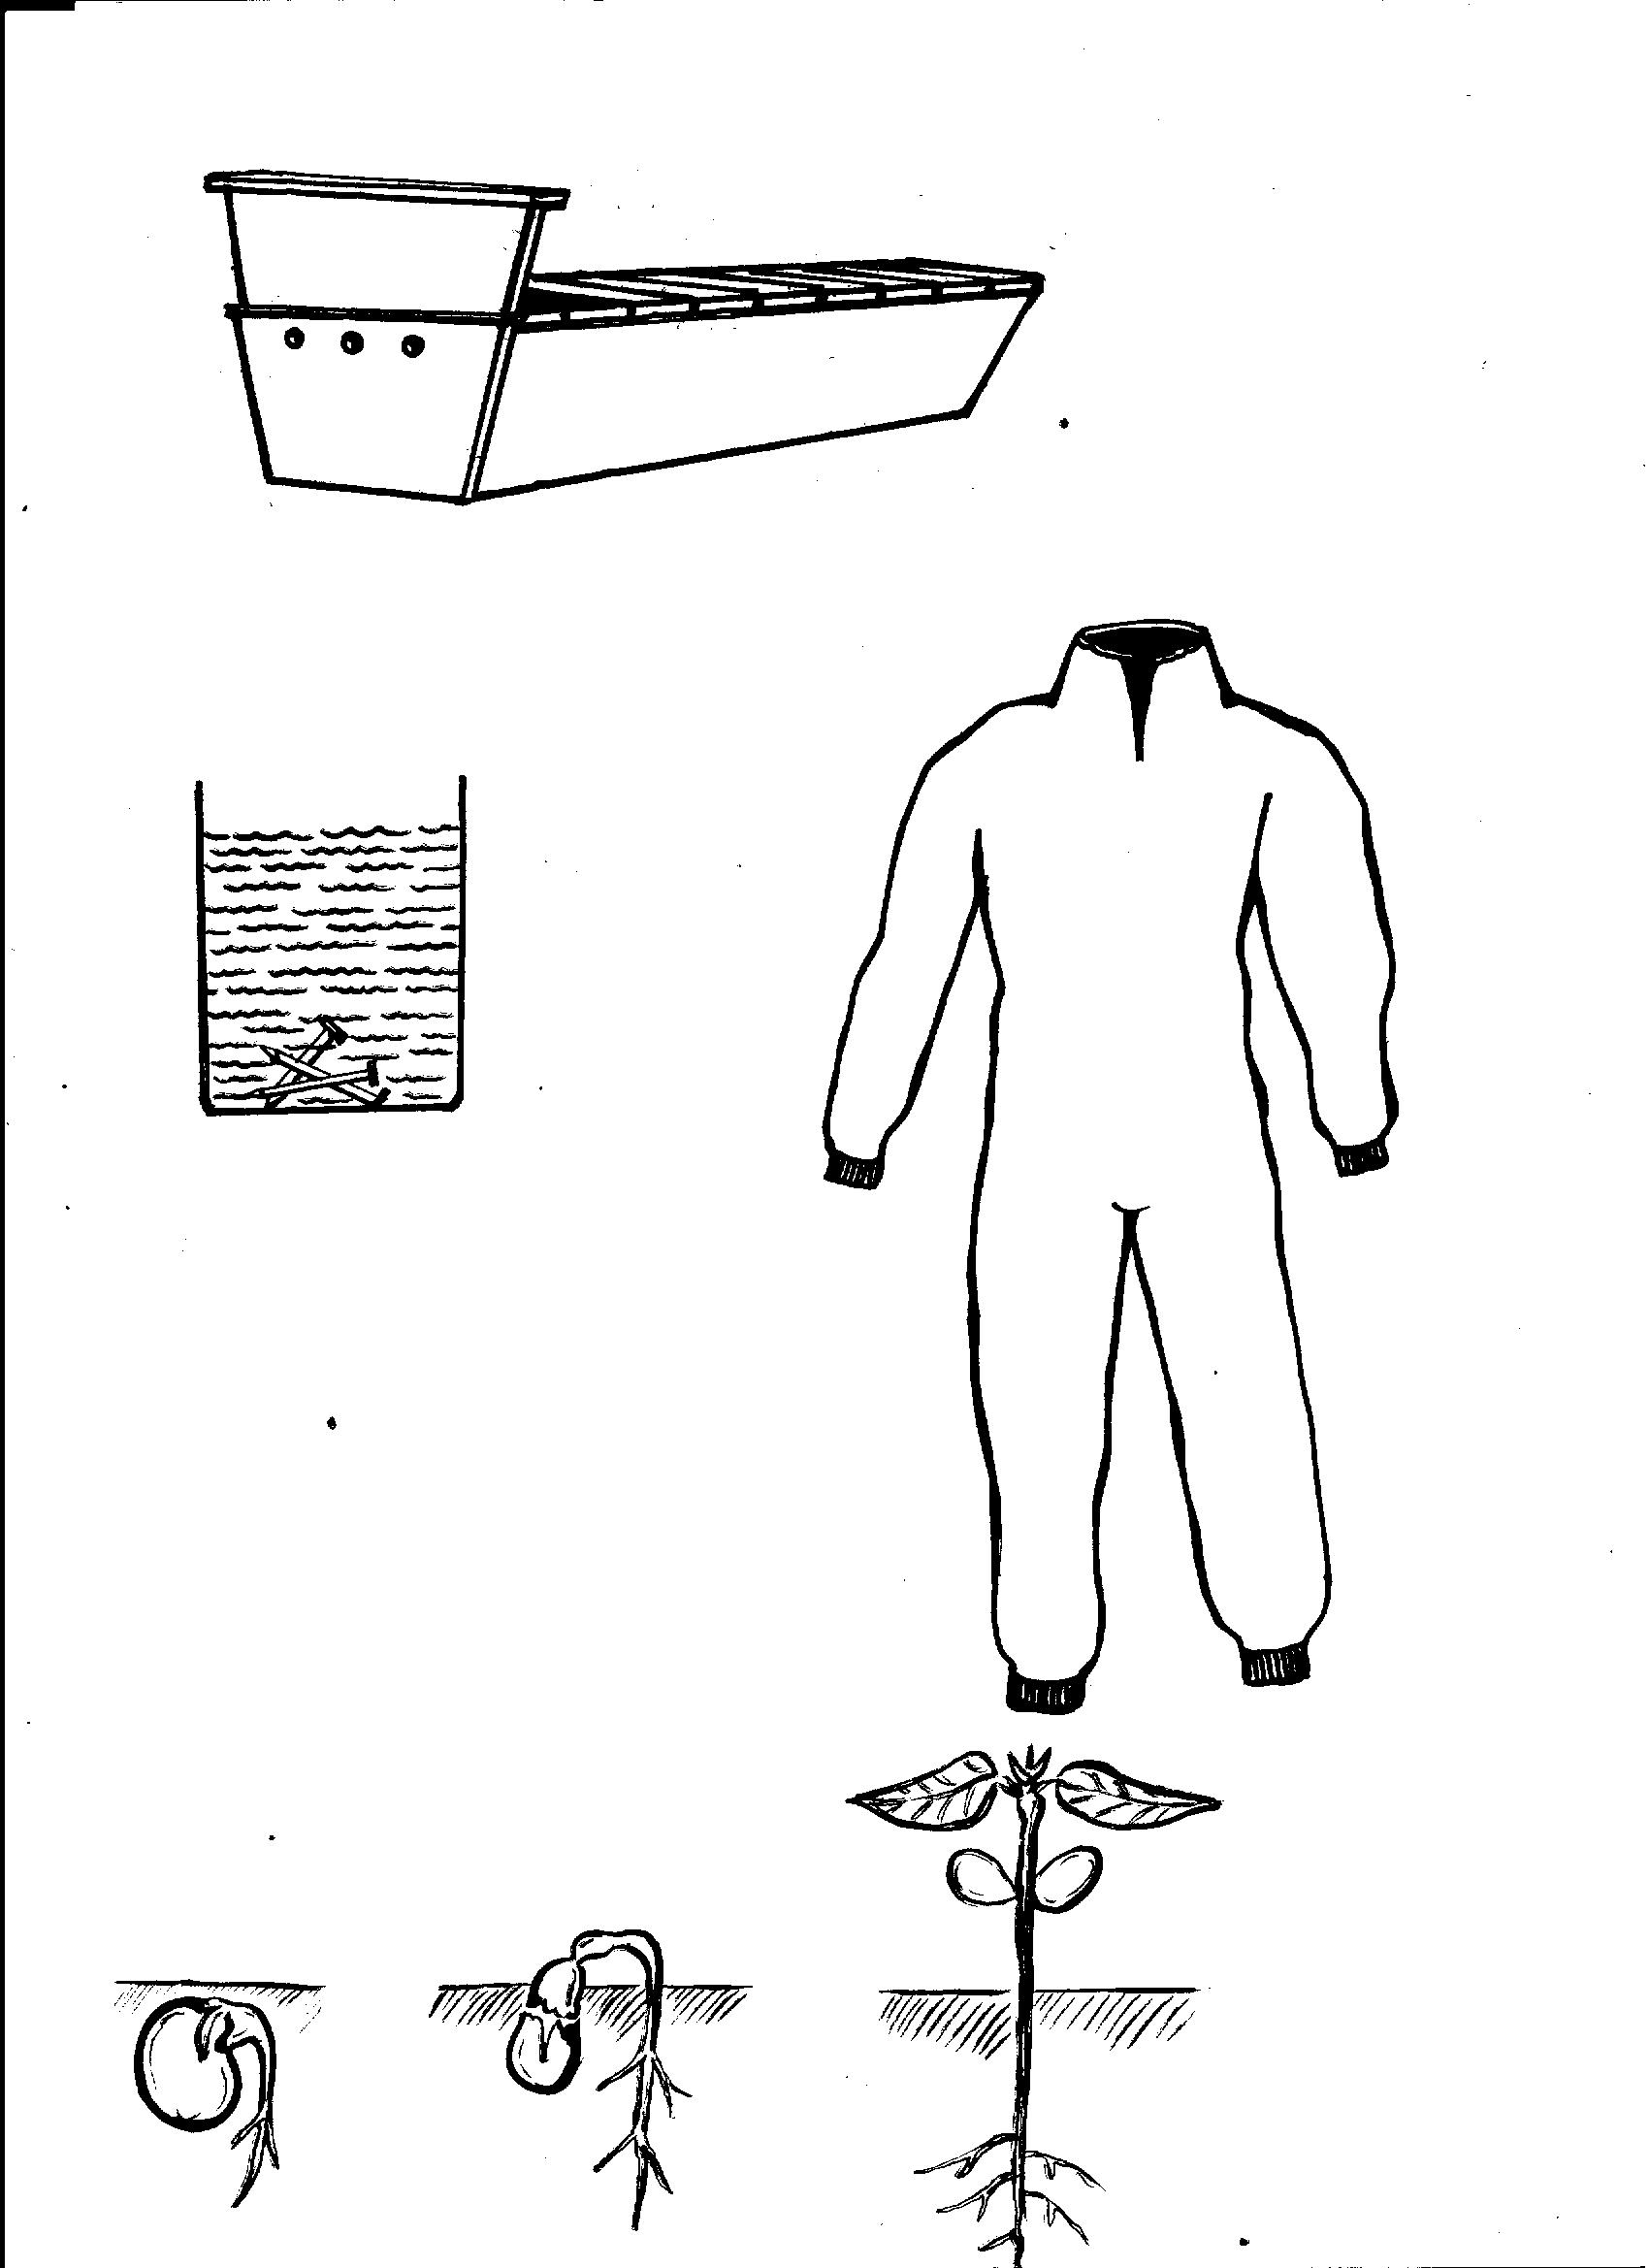

Examples of seeds that carryout hypogeal germination.
_ maize seeds.
_ sorghum seeds.
_ millet seeds.
_Rice seeds.
_oat seeds.
_ Barleys seeds.
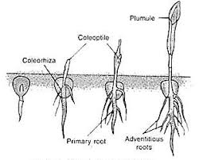
Stages of hypogeal germination.

Mini activity
1. Give any two examples of seeds that carryout hypogeal germination.
i) ____________________________________ ii) ____________________________________
2. Which type of germination where the cotyledon remains below the ground level.
___________________________________________________________________________
3. How do flowering plants reproduced.
___________________________________________________________________________
4. Apart from hypogeal germination, name one other type of germination.
____________________________________________________________________________
Conditions necessary for germination.
Condition are thing which must be present for the seed to germinate.
_ oxygen (air)
_ water (moisture)
_warmth.
Importance of each condition.
_ oxygen. Is used for seed respiration during germination.
_ water It softens the Testa for the embryo to come out.
It also dissolves the stored food to be used the embryo.
_ Warmth It enables action of the germination enzymes found in the seed.
_ It allows metabolism and growth of the seed.
Experiments about the condition the conditions necessary for germination
Air warmth present warmth +water present

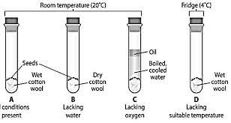

Air +water present Has air, water and warmth

All conditions present.
Observations.
1. Seeds in A did not germinate due to absence of water.
2. Seeds in B did not germinate due to absence of air (oil cut off oxygen supply)
3. Seeds in C did not germinate D germinated due to presence of air, water and warmth.
4. The seeds in experiment D germinated due to presence of air, water and warmth.
Conclusion: Seed need air, oxygen, water and warmth to germinate.
Mini activity.
1. Give any two examples of a plant planted using seeds.
i)________________________________ ii) ______________________________________
2. State the importance of the following conditions during germination.
Water_______________________________________________________________________
Oxygen _____________________________________________________________________
3. What do you understand by the term germination.
____________________________________________________________________________
4. How is plumule part of a bean seed important to the seed
____________________________________________________________________________
Seed viability.
Seed viability is ability of a seeds to germinate when all condition are present.
Seed dormancy. Is the state in which a seed fails to germinate even when provided with conditions needed for germination.
Importance of seed dormancy.
_It enables seeds to with stand very or very dry weather.
_ It allows seed and fruits to disperse.
Causes of seed dormancy.
_ When the seed coat does not allow in water.
_ Immaturity of the embryo of the seed.
Mini activity.
1. What is meant by seed viability.
____________________________________________________________________________
2. How important is seed dormancy?
____________________________________________________________________________
3. State any two causes of seed dormancy.
i) ______________________________________ ii) __________________________________
4. Write down any two characteristics of viable seeds.
i) __________________________________________________________________________
ii) __________________________________________________________________________
Tropism.
Key Learning principle.
Tropism is the growth movement of plants in response to stimuli in the environment.
Stimuli Is any change in the environment to which the plant is sensitive.
Types of tropism.
_ Phototropism.
_ Hydrotropism.
_ Chemotropism.
Phototropism.
Key Learning principles.
Is the growth movement of a plant in response to light.
Photo means light.
The shoots grow towards light and roots grow away from light.
Plants bend towards light because they need it for making food.

Diagram showing phototropism.
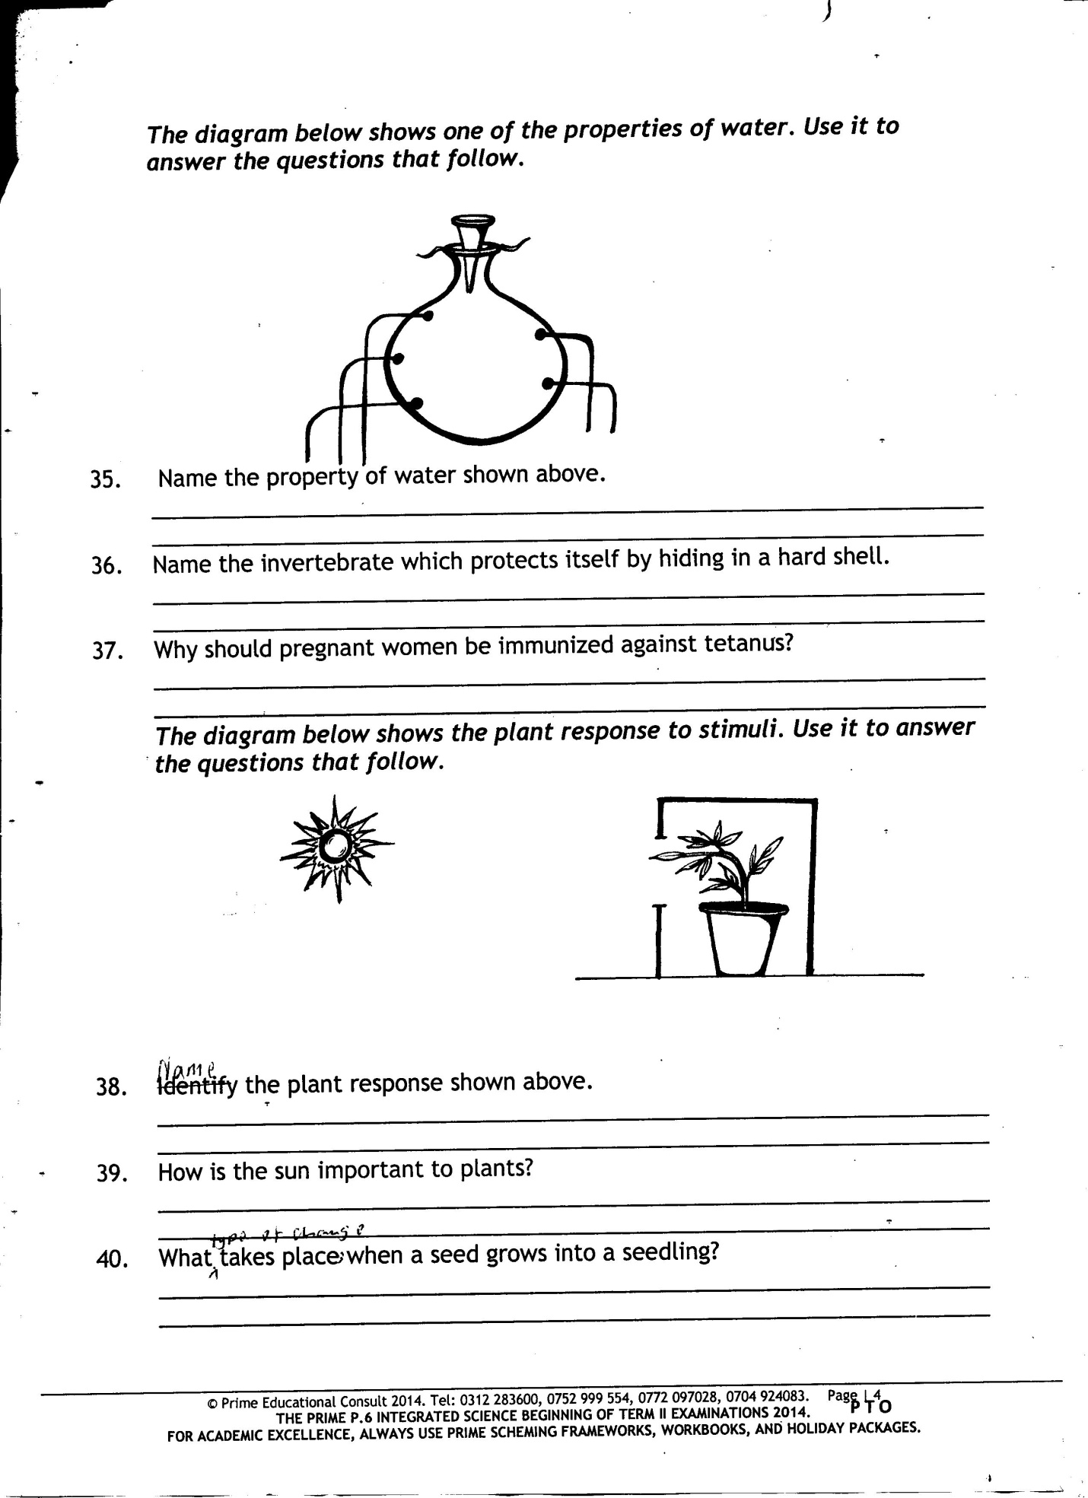

Hydropism.
Is the growth movement of the plant roots towards the source of water.
Means water.
Roots show positive hydrotropism while shoots show negative hydrotropism.
A diagram showing hydrotropism.

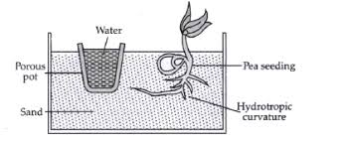

Geotropism ( gravitropism)
Is the growth movement in response to force of gravity.
The plant roots grow towards the force gravity.
Thigmotropism.
This is the plant growth response to touch contract.
Thigmo means touch.
It helps climbing plants to twin or clasp for support.
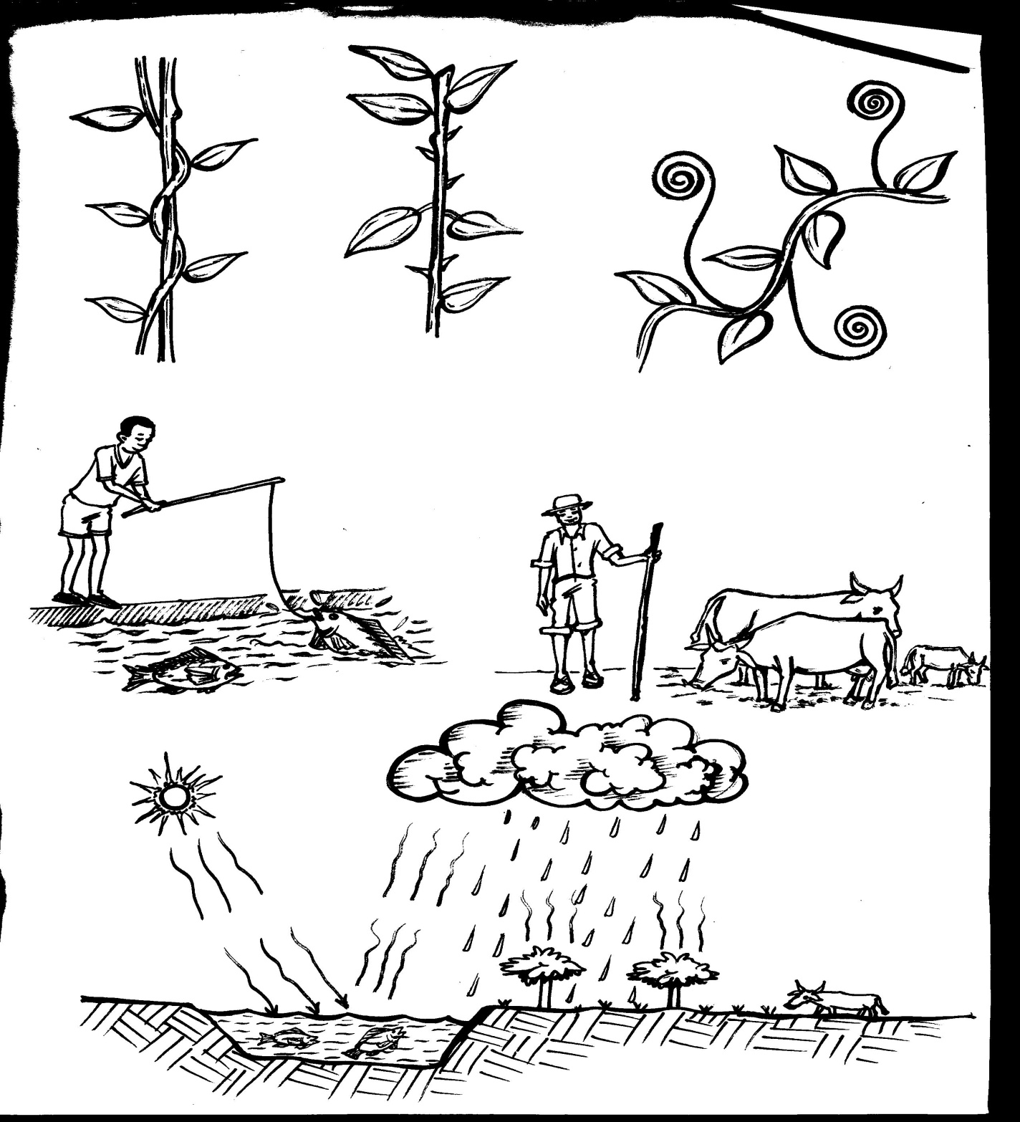
a plant using tendrils to climb for support.
tendril
twining

CHEMOTROPISM.
Is the growth movement of plant parts towards the source of chemicals other than water.
It Enables plant roots to grow to wards fertilizers.
Summary of types of tropism.
Tropism stimulus
1. Phototropism | Light
2. Geotropism | Force of gravity.
3. Hydrotropism | Water/ moisture
4. Thigmotropism | Touch
5. Chemotropism | Chemicals or Hormones

Importance of plants to people and animals.
- Some plants provide food to both- people and animals.
- Some plants are used as herbal medicine.
- Natural forests are tourist attractions
- Some plants are source of timber.
- Some plants provide materials for making crafts.
- Plants help in controlling soil erosion crops are also grown for selling.
- Some plants are cut to make firewood and charcoal.
- Some plants provide us with building materials.
- Some plants are used as mulches.
- Plants are source of manure.
- Plants are habitat for some animals.
MINI ACTIVITY.
1. What is meant by the term tropism.
____________________________________________________________________________
2. Name any two types of tropism in plants.
i) ___________________________________ ii) ___________________________________
3. In which one way are the following types of tropism important to plants
i) phototropism _____________________________________________________________
ii) Hydrotropism ____________________________________________________________
iii) chemotropism ___________________________________________________________
4. photo means ________________________________________________________________
5. How are plants important to people and animals?
_____________________________________________________________________________
CROPS.
Crops plants grown for purpose.
Types of crops commonly grown.
_ Fruits crops.
_ Cereals/ grain crops.
_ Vegetables crops.
_ Root crops.
Cereals/grains crops.
Are plants that bear grains.
_ They are sometimes called grains or monocot.
Examples of cereal crops
Rice crops.
Wheat crops.
Maize crops.
Oat crops sorghum crops.
Millet crops.
Barley crops.
MEGA ACTIVITY.
1. Give any two conditions necessary for the seed to germinate.
i) _____________________________ ii) __________________________________________
2. State the meaning of hypogeal germination.
____________________________________________________________________________
3. Why do plants with weak stem climb other plants?
____________________________________________________________________________
4. What is meant by the term seed dormancy?
____________________________________________________________________________
5. How is moisture important in terms of seed germination.
____________________________________________________________________________
6. Mention any two characteristics of viable seeds
i) ________________________________________________________________________
ii) ________________________________________________________________________
7. In which way are brightly colored petals of flowers important to plant?
___________________________________________________________________________
8. Apart from absorbing water, state any two functions of roots to plants.
i) _________________________________________________________________________
ii) _________________________________________________________________________
9. Identify the process in plants that increase the amount of oxygen in the environment.
__________________________________________________________________________
10. Why are beans plants classified among flowering plants.
__________________________________________________________________________
11. Write down the animal process which is similar to transpiration in plants.
__________________________________________________________________________
12. Mention any three importance of plant to people.
i) _________________________________________________________________________
ii) ________________________________________________________________________
iii) ______________________________________________________________________
13. Name this type of germination below.

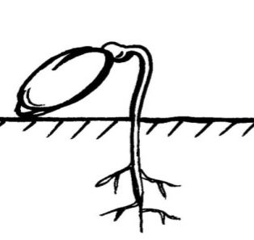

b) Mention any two plants that undergo the above type of germination.
i) ______________________________ ii) ______________________________________

14. Write the term used to mean plant response the following.
i) Light ____________________________________________________________________
ii) water ___________________________________________________________________
iii) chemical _________________________________________________________________
iv) Touch ___________________________________________________________________
15 a) Apart from hypogeal germination, name any one other type of germination.
____________________________________________________________________________
b) Why are mango seeds classified among epigeal germination?
____________________________________________________________________________
c) Give any one importance of germination in the environment.
____________________________________________________________________________
16. Name two importance of plant in the environment
i) ________________________________________________________________________
ii) _______________________________________________________________________

17. How do plants control soil erosion.
_______________________________________________________________________
18. Mention any one animal that we plant as habit.
________________________________________________________________________
19. What causes seed dormancy in germination.
_________________________________________________________________________
20. Give the role is played by the cotyledon during seed germination.
_________________________________________________________________________
21. Name the plant system in which flowers are found.
________________________________________________________________________

